JENKINS TASK-03

1. Create one jenkins job using the below code and create three stages.

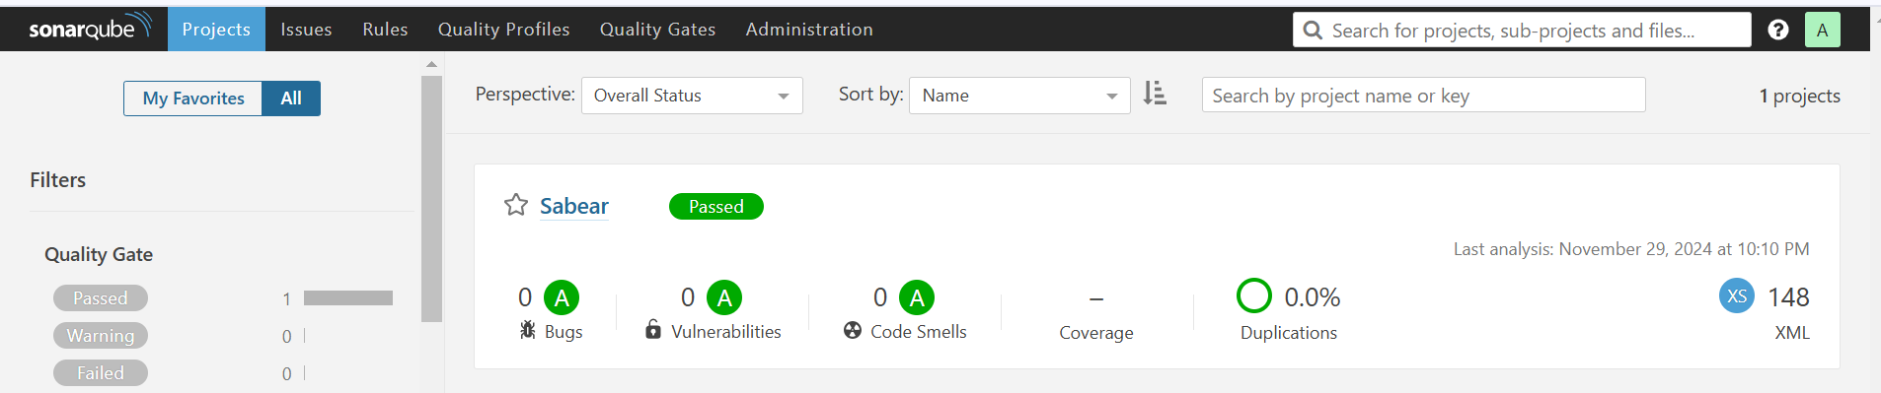

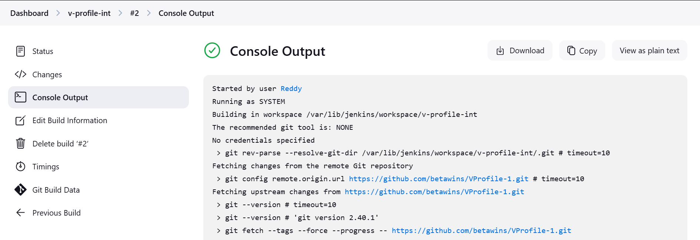

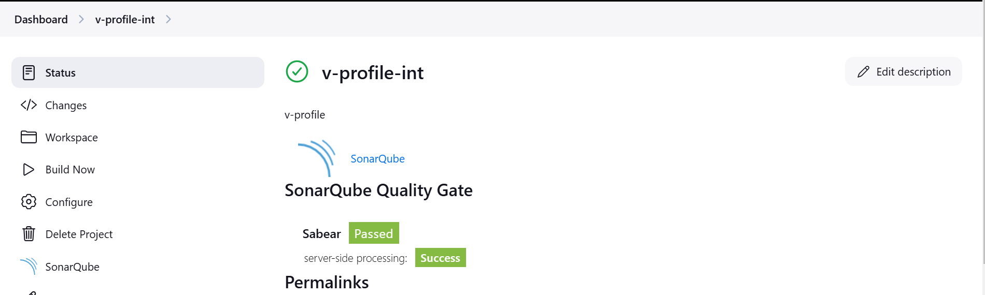

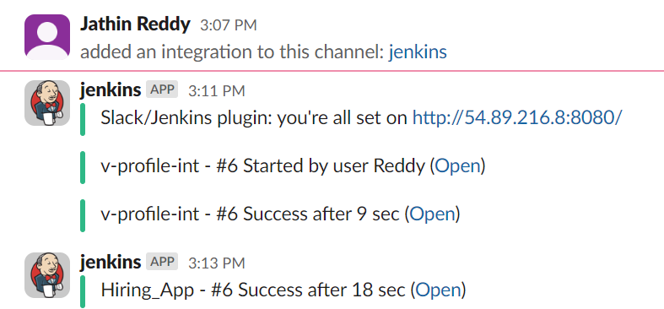

2) 1) Create one jenkins job using the below code and create three stages.

URL: https://github.com/betawins/hiring-app.git

